Phase-2

Predicting customer churn using machine learning to uncover hidden patterns

NAME: V Navaneetham
REGISTER NUMBER: 422623104001
INSTITUTION: University college of engineering panruti
DEPARTMENT: Computer science and engineering
DATE OF SUBMITION: 10/05/2025
Github Repository Link:
https://github.com/Navaneetham-25/Phase-2.git

🧩 Problem Statement
- Customer churn refers to the loss of customers or clients to a competitor, and it is a critical challenge for businesses, especially in industries like telecommunications, banking, and e-commerce.
- The problem lies in the difficulty of predicting which customers are likely to churn and the need to uncover hidden patterns to improve customer retention strategies.
- In this project, we aim to use machine learning to predict customer churn based on historical customer data, uncovering hidden patterns that could help businesses proactively reduce churn.

🎯 Project Objectives
- To predict customer churn using machine learning models based on historical customer data.
- To uncover hidden patterns in the data that indicate potential churn risks, enabling businesses to take preventive actions.
- : To explore various data preprocessing and feature engineering techniques to improve model accuracy.
- To visualize the results and interpret model insights in an easily understandable manner for business stakeholders

4. Data Description
- Dataset: The dataset typically includes customer demographics, transaction data, account details, service usage, customer interactions, and whether the customer churned or not.
- Churn Label: The target variable indicating whether the customer churned (1) or not (0).
- Feature Variables: Variables such as age, tenure, account type, monthly spend, customer service calls, contract type, internet service, payment method, etc.
- Data Size: The dataset could have thousands to millions of customer records, depending on the business scale.
- Time Period: Data collected over a specific period (e.g., last 12 months) to predict churn behaviour.

3. Flowchart of the Project Workflow
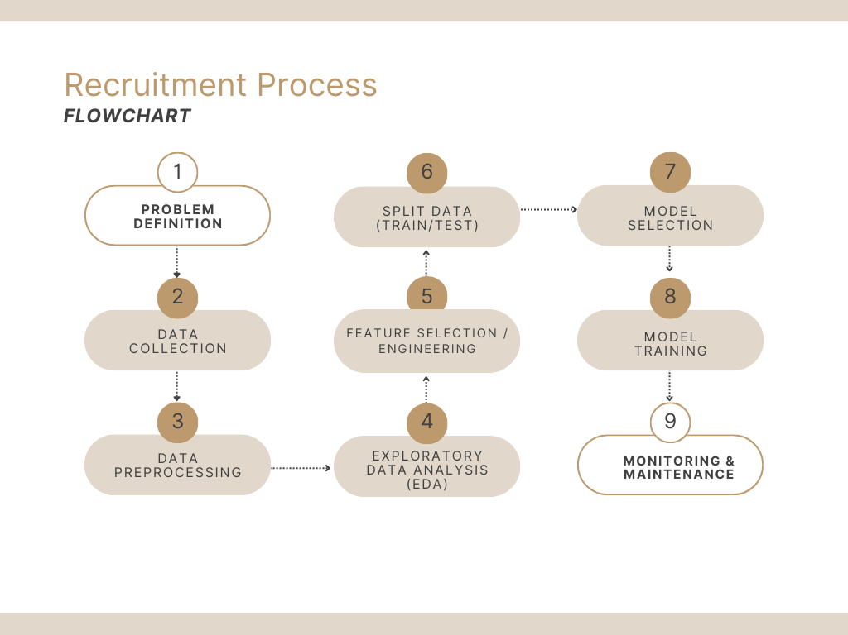

5. Data Preprocessing
- Missing Data Handling: Fill missing values using mean, median, mode, or use advanced imputation techniques.
- Outlier Detection and Removal: Identify outliers using statistical methods or visual techniques like box plots and remove or correct them.
- Categorical Encoding: Convert categorical features (e.g., contract type, payment method) into numeric format using methods like one-hot encoding or label encoding.
- Normalization/Standardization: Scale numerical features to a common range (e.g., using Min-Max scaling or Z-score normalization) to improve model performance.
- Handling Imbalanced Data: Use techniques like SMOTE (Synthetic Minority Over-sampling Technique) to balance the dataset if churn is much less frequent than non-churn.
- Feature Transformation: Apply logarithmic transformations or polynomial features if needed to improve model performance.
- Train-Test Split: Split the data into training and testing sets (e.g., 80% training, 20% testing) to evaluate model performance effectively.

📊 Exploratory Data Analysis (EDA)
- Univariate Analysis:
  - Visualize the distribution of each feature (e.g., histograms, box plots) to understand the spread and detect any abnormalities or trends.
  - Analyse the churn distribution (percentage of churn vs. non-churn) to assess the target variable balance.
- Bivariate/Multivariate Analysis:
  - Investigate relationships between features and churn (e.g., correlation heatmaps, scatter plots).
  - Explore how combinations of features (e.g., tenure and monthly spend) impact churn.
- Insights Summary:
  - Discover which factors contribute most to churn (e.g., customers with shorter tenure are more likely to churn).
  - Identify any significant patterns that could be useful for model building, such as correlations or outliers.

🧬 Feature Engineering
- Interaction Features: Create new features based on interactions between existing ones (e.g., customer tenure × monthly spend).
- Aggregate Features: Derive aggregated features like the average number of customer service calls per month or the total transaction amount in the last 6 months.
- Lag Features: Create lag variables to capture changes in the customer’s behavior over time (e.g., the change in spending behavior over the last quarter).
- Text Features: If there are textual customer feedback or complaints, use NLP (Natural Language Processing) to extract sentiment or key phrases.
- Datetime Features: Extract useful components from timestamp data, like month, day, or year, to identify seasonality patterns.

🧠 Model Building
- Model Selection: Choose machine learning algorithms like Logistic Regression, Decision Trees, Random Forest, Gradient Boosting Machines, or Neural Networks.
- Hyperparameter Tuning: Use techniques like Grid Search or Random Search to optimize hyperparameters for the chosen models.
- Cross-Validation: Apply k-fold cross-validation to assess model performance on unseen data and avoid overfitting.
- Model Evaluation: Evaluate model performance using metrics like accuracy, precision, recall, F1-score, and AUC (Area Under the Curve).

📈 Visualization of Results & Model Insights
- Model Performance Graphs: Plot ROC curves, precision-recall curves, or confusion matrices to visualize model performance.
- Feature Importance: Visualize which features have the most impact on the churn prediction (e.g., using feature importance from tree-based models).
- Churn Probability Distribution: Plot the predicted churn probabilities across all customers to identify customers at high risk of churn.
- Model Comparison: Compare the performance of different models using bar charts or tables to determine which model is most effective.

🧰Tools and Technologies Used
💻Programming Language
- Python
📚 Libraries:
- Pandas (data manipulation)
- NumPy (mathematical operations)
- Matplotlib
- Seaborn (visualization), Scikit-learn (machine learning algorithms and metrics), XGBoost (advanced model building).
📒 Jupyter Notebooks
- interactive coding
- data exploration
- visualization

⚙️Deployment Tools:
- Flask or FastAPI (for building a simple API)
- cloud platforms like AWS or Google Cloud for model deployment (optional)

Team Members and Roles
Team members | Role | Responsibilities
M Hariprasath  (Project lead) | Data collection and Data cleaning | Perform data cleaning and transformation
M Santhosh | Feature Engineering and Deployment | Define scope, timeline and Ensure data compliance and ethics.
R Dhawan | Model Evaluation | Conduct EDA and feature engineering and interpret and explain model results
V Navaneetham | Visualization & Interpretation | Ensure dashboard is user friendly and responsive and Handle basic back end/frontend integration
S Kanagavally | Exploratory Data Analysis (EDA) and Model Building | Prepare models for production and Ensure scalability and reliability

